Developing ABAP Program
프로그램명 | ZEX1_8_ ABAP_A ##
Subprocess | Report Program / Transaction Code
항공사 정보를 입력하는 DBC Program을 작성한다.(제한시간 2시간)

1. SCARR Table을 ZSCARR_<Course Name>_##으로 복사한다.

2. 아래의 코드로 ZEX_1_8__<Course Name >_##을 만들고 동일한 이름의 트랜젝션 코드를 생성한다.
소스코드의 Insert문장의 테이블 이름을 1에서 복사한 테이블 이름으로 교체한다.
DATA: ls_insert TYPE zscarr_sol_00.
PARAMETERS: pa_car TYPE zscarr_sol_00-carrid,
pa_name TYPE zscarr_sol_00-carrname,
pa_cur TYPE zscarr_sol_00-currcode,
pa_url TYPE zscarr_sol_00-url.
AT SELECTION-SCREEN.
START-OF-SELECTION.
PERFORM insert_data.
*&---------------------------------------------------------------------*
*& Form INSERT_DATA
*&---------------------------------------------------------------------*
* text
*----------------------------------------------------------------------*
* --> p1 text
* <-- p2 text
*----------------------------------------------------------------------*
FORM insert_data .
ls_insert-carrid = pa_car.
ls_insert-carrname = pa_name.
ls_insert-currcode = pa_cur.
ls_insert-url = pa_url.
INSERT zscarr_<Course Name>_00 FROM ls_insert.
IF sy-subrc <> 0.
MESSAGE 'Error' TYPE 'E'.
ELSE.
MESSAGE 'Success' TYPE 'S'.
ENDIF.
ENDFORM.

3. ZEX_1_8__<Course Name >_##프로그램의 ABAP Recoder(T-code: SHDB) 를 사용하여 Recording을
기록한다.

- T-Code: SHDB실행
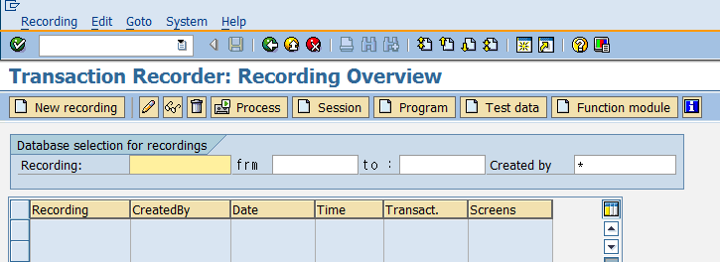
- New recoding 실행
Recoding: Z_<Course Name>_##
Transaction Code: ZEX_1_8_<Course Name>_##
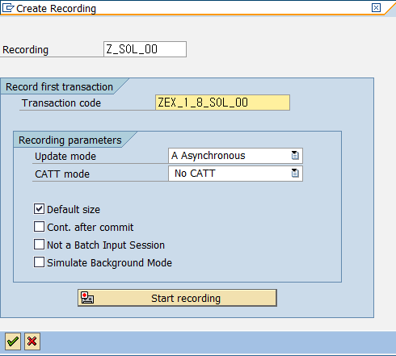

- Recording
아래그림과 같이 정보 입력 후 실행 후 Back 버튼 선택
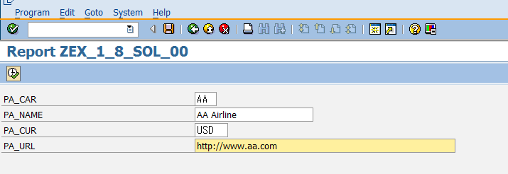

- Recording정보 확인 후 저장 후 Back 버튼 선택
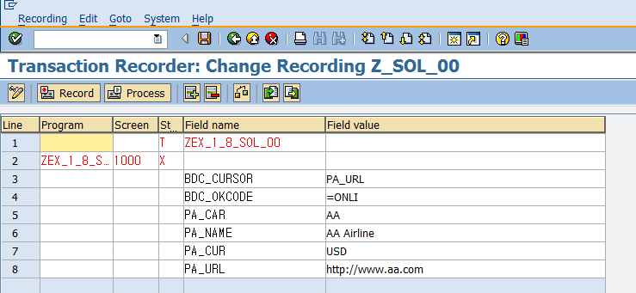

3. ZEX_1_9__<Course Name >_## BDC 프로그램 생성
아래의 소스코드를 복사하여 To-Do 부분을 레코딩정보에 맞게 수정한다.
DATA: lt_bdcdata TYPE TABLE OF bdcdata.
DATA: ls_bdcdata TYPE bdcdata.
DATA: messtab LIKE bdcmsgcoll OCCURS 0 WITH HEADER LINE.
PARAMETERS ctumode LIKE ctu_params-dismode DEFAULT 'N'.
PARAMETERS: pa_file TYPE rlgrap-filename.
DATA: BEGIN OF record,
* data element:
pa_car_001(003),
* data element:
pa_name_002(020),
* data element:
pa_cur_003(005),
* data element:
pa_url_004(255),
END OF record.
*** End generated data section ***
DATA: lt_record LIKE TABLE OF record.
AT SELECTION-SCREEN ON VALUE-REQUEST FOR pa_file.
PERFORM get_file.
START-OF-SELECTION.
PERFORM upload_file.
LOOP AT lt_record INTO record.
* To-do: lt_bdcdata Internal Table을 레코딩 정보를 참조하여 채운다.
* Call Transaction 호출.
ENDLOOP.
*&---------------------------------------------------------------------*
*& Form GET_FILE
*&---------------------------------------------------------------------*
* text
*----------------------------------------------------------------------*
* --> p1 text
* <-- p2 text
*----------------------------------------------------------------------*
FORM get_file .
DATA: lt_file TYPE filetable.
DATA: ls_file LIKE LINE OF lt_file.
DATA: lv_rc TYPE i.
cl_gui_frontend_services=>file_open_dialog(
CHANGING
file_table = lt_file " Table Holding Selected Files
rc = lv_rc " Return Code, Number of Files or -1 If Error Occurred
EXCEPTIONS
file_open_dialog_failed = 1
cntl_error = 2
error_no_gui = 3
not_supported_by_gui = 4
OTHERS = 5
).
IF sy-subrc = 0.
READ TABLE lt_file INTO ls_file INDEX 1.
pa_file = ls_file-filename.
ENDIF.
ENDFORM.
*&---------------------------------------------------------------------*
*& Form UPLOAD_FILE
*&---------------------------------------------------------------------*
* text
*----------------------------------------------------------------------*
* --> p1 text
* <-- p2 text
*----------------------------------------------------------------------*
FORM upload_file .
DATA: lt_raw TYPE truxs_t_text_data.
CALL FUNCTION 'TEXT_CONVERT_XLS_TO_SAP'
EXPORTING
i_tab_raw_data = lt_raw
i_filename = pa_file
TABLES
i_tab_converted_data = lt_record
EXCEPTIONS
conversion_failed = 1
OTHERS = 2.
IF sy-subrc <> 0.
* Implement suitable error handling here
ENDIF.
ENDFORM.
*----------------------------------------------------------------------*
* Start new screen *
*----------------------------------------------------------------------*
FORM bdc_dynpro USING program dynpro.
CLEAR ls_bdcdata.
ls_bdcdata-program = program.
ls_bdcdata-dynpro = dynpro.
ls_bdcdata-dynbegin = 'X'.
APPEND ls_bdcdata to lt_bdcdata.
ENDFORM.
*----------------------------------------------------------------------*
* Insert field *
*----------------------------------------------------------------------*
FORM bdc_field USING fnam fval.
CLEAR ls_bdcdata.
ls_bdcdata-fnam = fnam.
ls_bdcdata-fval = fval.
APPEND ls_bdcdata to lt_bdcdata.
ENDFORM.
*----------------------------------------------------------------------*
* Start new transaction according to parameters *
*----------------------------------------------------------------------*
FORM bdc_transaction USING tcode.
DATA: l_mstring(480).
DATA: l_subrc LIKE sy-subrc.
* batch input session
REFRESH messtab.
CALL TRANSACTION tcode USING lt_bdcdata
MODE ctumode
UPDATE 'L'
MESSAGES INTO messtab.
l_subrc = sy-subrc.
WRITE: / 'CALL_TRANSACTION',
tcode,
'returncode:'(I05),
l_subrc,
'RECORD:',
sy-index.
LOOP AT messtab.
MESSAGE ID messtab-msgid
TYPE messtab-msgtyp
NUMBER messtab-msgnr
INTO l_mstring
WITH messtab-msgv1
messtab-msgv2
messtab-msgv3
messtab-msgv4.
WRITE: / messtab-msgtyp, l_mstring(250).
ENDLOOP.
SKIP.
REFRESH lt_bdcdata.
ENDFORM.

4. Excel upload 파일준비(XLS형식으로 되어 있어야함)
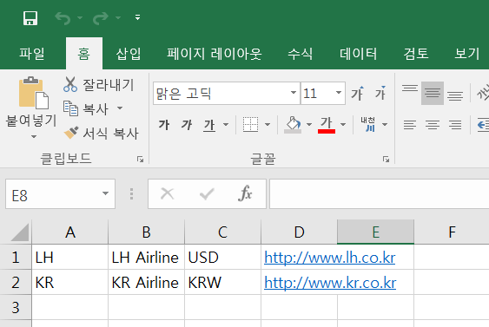

5. ZEX_1_9_<Course Name>_##프로그램 실행 및 테스트
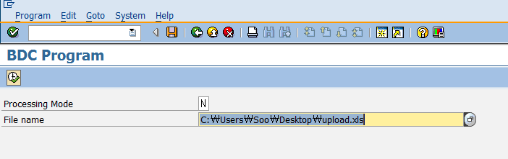

5. 프로그램이 완성되면 Transaction Code를 생성한다.(미생성시 0점 처리)
- Transaction Code명은 프로그램 이름과 동일

